McKinney ISD School: Sample School
Annual Report Website/Twitter: @awesomeschoolcounselor

Mission: The MISD counselors are a diverse group of service oriented professionals who believe in connecting our students, parents, schools and community with tools and resources for academic, social, and emotional success. MISD Counselors champion the core beliefs of MISD through a focus on:

- Individualized success
- Academic achievement and planning for the future
- Social connections
- Respect and responsibility
- Emotional well-being and personal growth

MISD counselors are responsive to campus needs and provide services in accordance with TEC 33.005 and in alignment with the Texas Model for Comprehensive School Counseling Programs. For more information on counselor activities, please review the McKinney ISD Counseling Mission & Framework available at: www.tinyurl.com/frameworkmisd.

Counseling by the Numbers:
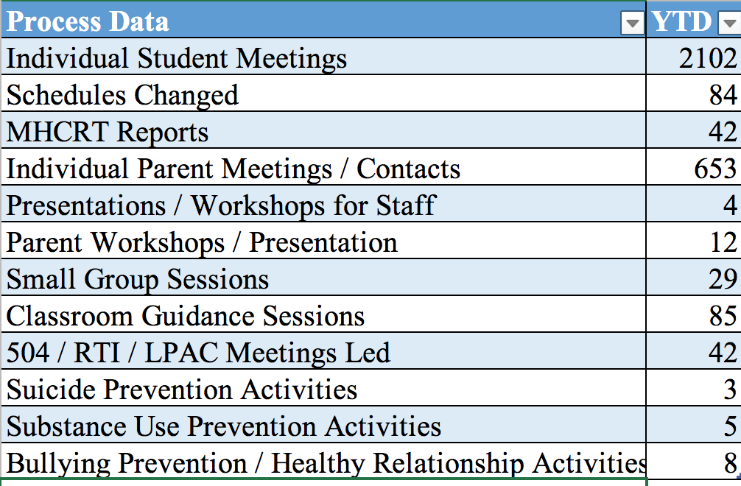 | 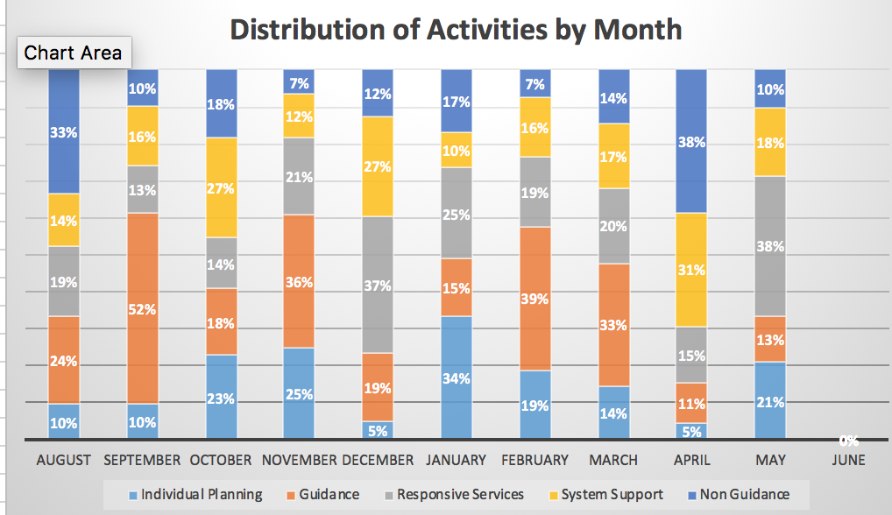
Campus/District Committees and Community Partnerships: McKinney Vento Liaison; Red Ribbon week - anti Bullying Week and Anti Bullying coordinator; Wellness Week (for Staff) facilitator; Career exploration and Careers that Move(Career Day on Wheels); Sponsor of Student Leadership Team (extracurricular club for student leaders); Random Acts of Kindness Lead; Angel Tree Coordinator; Holiday Food Drive; Watch DOGS program coordinator; Counselor advisory committee member

Program Alignment:
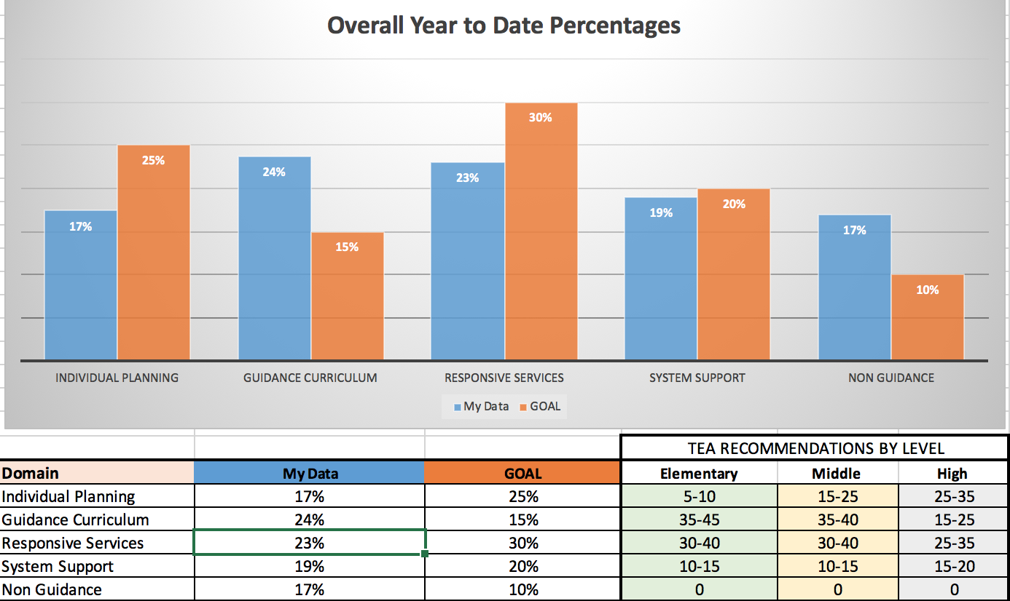 | School at a Glance:  Grade levels: PreK-5th grade  Total Student Enrollment: 650  504: 65 (10%)  At-risk: 307 (47%)  ELL: 32 (5%)  GT: 32 (5%)  SPED: 45 (7%)  F/R: 320 (49%)  M/V: 20 (3%)  Top Identified Needs from 19-20 CPP:  - Improve transition guidance for kindergarten, including emotional regulation  - Conflict Resolution for 5th graders  - Restorative Practices to improve student engagement

CPP Goals
Individual Planning:  List goal from CPP | Plan of Action: No later than March 27, 2020, the school counselor will develop provide a guidance lesson to all 5th grade classrooms describing the middle school course selection process. The school counselor will meet individually with all 5th grade students to support and address student academic, personal, social, and career needs that are developmentally appropriate students transitioning from 5th to 6th grade.  Results: □ Met Goal X Some Progress Made □ Goal discontinued on date: □ Revised Goal:  Reflection: I was able to partially accomplish my goal in that I provided guidance lessons to students in all the 5th grade classrooms. Additionally, I was able to meet individually with 85 of the 95 5th grade students. There were 10 students who I was unable to meet within the identified window.
Responsive Services:  List goal from CPP | Plan of Action: The school counselor will develop and implement a small group for students impacted by grief or other trauma by November, 2020. Sessions will focus on recognizing emotions, coping strategies and ways to seek support.  Results: X Met Goal □ Some Progress Made □ Goal discontinued on date: □ Revised Goal:  Reflection: Six students were identified to participate in the first small group. A second small group was conducted in January to serve 4 additional students. In both groups, post-tests showed student growth in identifying feelings and naming coping strategies. Next year I will plan on offering at least one group every quarter.
System Support:  List goal from CPP | Plan of Action: By the beginning of the school year (August, 2020), the school counselor will train all professional staff members(through a larger group presentation) on child protective reporting protocols and procedures. As a result of the training, 100% of the staff will be able to name at least 2 forms of neglect/abuse.  Results: □ Met Goal □ Some Progress Made □ Goal discontinued on date: X Revised Goal:  Reflection: After reflection and planning, the previous goal has been modified to reflect - By the beginning of the school year (August, 2020), the school counselor will create and implement a training, made available to all professional staff members on child protective reporting protocols and procedures. Staff members will be able to name at least 2 forms of neglect/abuse.

Guidance Top Five Activities
CCR | Character Education | Healthy Relationships | Substance Use Prevention | Suicide Prevention
1 guidance lesson on career awareness for grades k-2; Careers that Move for 3rd grade; guidance lessons in fall and spring for 4th graders on goal setting and quarterly lessons for 5th graders on transitioning to 6th grade | Daily pledge and chant, character bulletin board; monthly livekind challenges; k-5 monthly 6 pillars of character lessons delivered in circle time | k-5 September bullying prevention lessons; Space camp for kindergarten; Who lessons for 1-3 grade; lesson on Saying No and Boundaries for grades 4 & 5; Conflict resolution lesson for 5th grade | “Pill or candy” display in the cafeteria; parent brown bag with guest speaker from Poison Control Center | Small group for students experiencing a mood disorder; parent brownbag session on recognizing depression; posters to encourage students to talk to a trusted adult
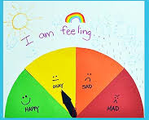
Data Highlight # 1  3 guidance lessons were completed for Kindergarten students to help them identify their strong feelings and name at least one strategy to cope. Prior to the lesson, only 20% of students could identify more than two feelings. 10% could name a strategy to cope. Two weeks after the lesson, 95% of students could name two or more feelings and 60% could name at least one coping strateghy. Teachers also reported that more students were indepedently managing frustration. | 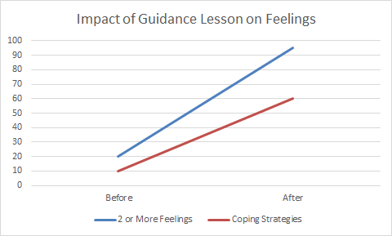
Data Highlight #2
Number of discipline referrals for fifth graders in 2020-2021 school year decreased significantly from 2019-2020. In 2019 school year 49 referrals were made and in 2020 there were only 12 referrals made, which is a 76% decrease in fifth grade referrals.

Major Accomplishments/Stakeholder Feedback:
2020 recipient – Counselors Reinforcing Excellence for Students in Texas (CREST)
Staff:
· “I enjoyed the guidance lessons. The students enjoyed and took away numerous ideas and can apply them in the real world.”
· “All I can say is that you were awesome!! I have never met such an efficient and caring counselor.”
· “Continue as is! You are the first school counselor I have had to actually do just that. You do a great job.”
· “We are so lucky to have you on our campus!”
Students:
· “Thank you for being my hero. You are my hero because you help me when I have a hard time.”
· “Thank you for making me better and do something. Thank you for making me not lie anymore.” “Thank you for calming me down almost every day and on math!”
Principal:
· “Thank you for making sure our students’ emotional needs are met! You do an awesome job seeking out ways to help our students! Thank for all that you do, what you do each and every day!”
· “Thanks for the awesome job you did organizing the STAAR Pep Rally! I appreciate your willingness to listen and chip in around campus in any way possible.”

Opportunities for Growth:
Overall this year has been professionally fulfilling. My campus counseling program earned the 2020 CREST award! In addition, several of the goals I identified in the CPP were met, partially met, or slightly modified. I see opportunities for growth in the following areas:
- increase parent/guardian/family connection to the campus
- decrease referrals for 3rd grade boys by adding lessons on anger management in the 3rd quarter and adding more brain breaks
- increase responsive services by focusing on small group intervention for coping skills
- working with a partner on At-Risk identification

